Kolář Jan¹, Kučerová Andrea², Jakubec Pavel¹, Vymazal Jan¹

Seed bank of Littorella uniflora (L.) Asch. in central Europe - monitoring and experiments

¹ Czech University of Life Sciences, Faculty of Environmental Sciences, Kamýcká 129, Prague 6, Czech Republic
² Institute of Botany, Czech Academy of Sciences, Dukelská 135, Třeboň, Czech Republic
corresponding author: kolarj@fzp.czu.cz, +420775694372

Statistical analyses
Effects of sediment type and burial depth on maximum germination were determined using a two-way ANOVA (StatView for Windows, SAS Institute Inc.). Prior to analysis, all percent data were arcsine square root transformed. Normality was confirmed and homogeneity of variance verified with Cochran’s test. Results are presented as non-transformed means.

Results
Seed bank on the historical localities
In total, 173 seeds were found at 10 sites with the historical occurrence of L. uniflora. The mean value was 17.3 seed per site and 0.57 seed per one soil sample. However, the sums differed substantialy among sites (Table 1). Most of the seeds found (n = 157; 90.7 % in total) came from the Svět fishpond. No seed of Littorella was found at four localities, in other three localities only very low number (1;1 or 2 seeds, respectively).

Seed bank on the recent localities
In total, 2466 seeds were found at 8 sites with the recent occurrence of L. uniflora (Table 1). The mean value was 308.25 seeds per site and 10.27 seed per one sample, i. e. in 125 ml of sediment. The largest number of seeds (n = 1390) was found at the Láz water reservoir where the size of L. uniflora population was estimated at millions of individuals, many of them flowering every year. The lowest amount of seeds (n = 8) was found at the Nový fishpond, no seed was able to germinate during the gemination test made in the climatic chamber (Table 2). The population is only hundreds of individuals, the last flowering was observed more than 10 years ago at this locality. On the other hand, significantly highest number of germinated seeds (3.3±1.2, z-value 2.176, p = 0.0296) came from the Osika fishpond with population of thousands of individuals with last massive flowering in 2007??? (Table 2).

Germination from different burial depth

The burial depth had highly significant effect on the germination of Littorella uniflora seeds in both open greenhouse (z- value = 9.667, p < 2.2e-16 ***) and in climatic chamber (z-value = -3.088, p < 0.00202 **), respectively. No seed was able to germinate/penetrate from the depth of 3 or 5 cm in both tests. The mean germination ability from the depth of 1 cm was 34.7%±7.5 in open greenhouse and 9.3%±6.8 in climatic chamber, respectively. In both tests the highest number of seeds germinated in control, i.e. on the wet filter paper (almost 53.3%±5.0 in open greenhouse and 13.3%±10.5 in climatic chamber, respectively).

Germination on different substrates

The sediment type had highly significant effect on the germination of Littorella uniflora seeds (z-values = 107.05, p < 2.2e-16 ***). No seed germinated on topsoil. Low number of seeds germinated on mixture of sand + peat (3.0%±4.6*) and sand + clay (4.0%±9.2*). The higher number of seeds germinated on pond mud (24.0%±16.2*). However, the highest number of seeds germinated in control, i.e. on the wet filter paper (almost 49.0%±18.7***).
Table 1 Summary of historical and recent Littorella uniflora localities in the Czech Republic, their characteristics, number of seeds and estimated sizes of L. uniflora population in 2015.

Table 2. Mean number of seed from recent localities germinated during the germination test in climatic chamber in January-February 2015. The significantly different means are in bold and marked by **, n = 25 (only 8 seeds was tested in the Nový fishpond).
Recent locality | Mean±s.d. | Date of last flowering approx.
Karhov | 0.7±0.5 | 2007
Mrzatec | 1.0±1.4 | ??
Nový | 0± n.d. | ??
Rytíř | 2.0±0.0 | 2014
Králek | 2.7±0.5 | ??
Staňkov | 0.3±0.5 | 2001
Osika | 3.3±1.2** | 2007/2014
Láz | 1.7±1.7 | 2014

Table 3 Chemical analysis of the substrates

 | pH | conduct.  uS/cm | TN  g/kg | TP  mg/kg | Al  mg/kg | Ca  mg/kg | Mg  mg/kg | TOC  % in dry matter
sand | 4.65 | 133.9 | 1.254 | 505.133 | 1.0 | 36.5 | 8.2 | 0.33
clay | 4.67 | 96.1 | 1.064 | 371.772 | 26.9 | 17.7 | 4.7 | 0.39
topsoil | 4.61 | 250.0 | 4.265 | 864.519 | 1.0 | 85.6 | 6.5 | 1.66
peat | 3.90 | 223.0 | 18.243 | 317.246 | 2.0 | 454.3 | 11.2 | 38.60
pond mud | 5.80 | 258.0 | 10.553 | 721.703 | 1.0 | 86.3 | 18.8 | 5.58
sand/peat | 4.11 | 191.8 | 4.386 | 389.587 | 10.4 | 48.3 | 14.6 | 3.91
sand/clay | 4.70 | 99.7 | 1.026 | 386.269 | 31.4 | 23.7 | 5.7 | 0.35
sand/pond mud | 5.72 | 191.2 | 3.309 | 607.916 | 16.6 | 67.9 | 14.7 | 1.54

Fig. 2. Mean germination (in %) of Littorella uniflora seeds tested on different sediment type in open greenhouse (near natural conditions), the substrates with significant differences in germination marked by * (p = 0.05) and *** (p = 0.001). The effect of sediment was highly significant (z-values = 107.05, p < 2.2e-16 ***). No seed geminated on topsoil, n = 90.
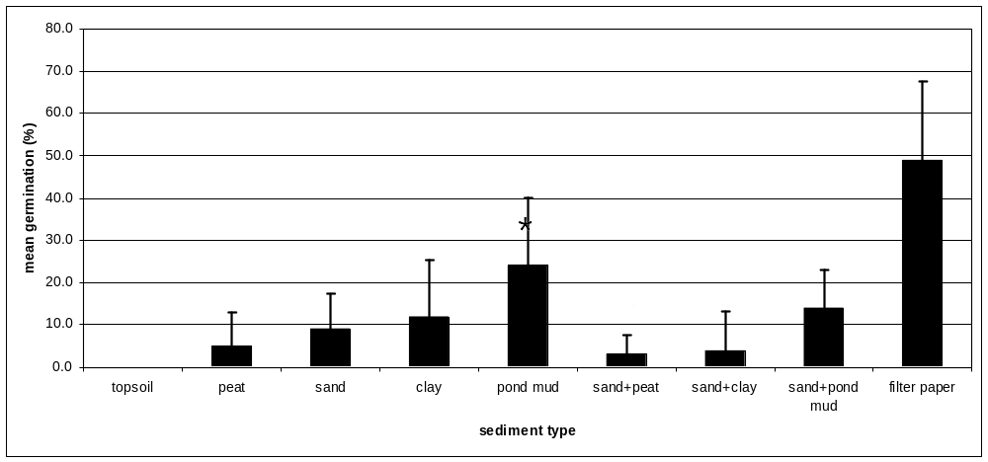

Table 3 Effect of different burial depth on gemination of Littorella uniflora seeds tested in open greenhouse (near natural conditions) and in climatic chamber. The significant differences are marked by different letters.

 | open greenhouse | climatic chamber
burial depth  (cm) | mean germination (%)±s.d. | mean germination (%)±s.d.
1 | 34.7±7.5*** | 9.3±6.8***
3 | 0.0±0.0 | 0.0±0.0
5 | 0.0±0.0 | 0.0±0.0
control (filter paper) | 53.3±5.0 | 13.3±10.5

Table 4 Mean germination (in %) of Littorella uniflora seeds tested on different sediment type in open greenhouse (near natural conditions), the substrates with significant differences in germination marked by * (p = 0.05) and *** (p = 0.001). The effect of sediment was highly significant (z-values = 107.05, p < 2.2e-16 ***). No seed geminated on topsoil, n = 90.
 | mean gemination (%) | s.d.
topsoil | 0.0 | 0.0
peat | 5.0 | 8.1
sand | 9.0 | 8.3
clay | 12.0 | 13.3
pond mud | 24.0* | 16.2
sand+peat | 3.0* | 4.6
sand+clay | 4.0* | 9.2
sand+pond mud | 14.0 | 9.2
filter paper | 49.0*** | 18.7

